Lab 4: Implementing Nested Procedures and Sorting

Task 1
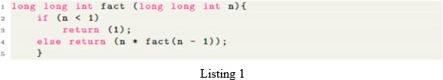
Translate the C function shown in Listing 1 into RISC-V assembly to calculate the factorial using the iterative approach. How does the stack get populated? Observe and comment on the working of code.
ANS) The stack does not get populated because the iterative solution uses a loop instead of function calls, so we dont need to save return addresses on the stack.

Code:

Output

Task 2
The nth triangular number is like a factorial but instead of a product we use a summation: https:
//en.wikipedia.org/wiki/Triangular_number
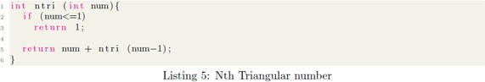

Translate the above C function to calculate the Nth Triangular number into RISC-V assembly. You should also write the wrapper code, i.e., which calls this function with an argument and then displays the result returned by this function.
Since there’s recursion going on, you will need to adjust the stack so that you store the return 4 address as well as any useful variables of the caller on the stack before calling the callee. Show the result computed. How does the stack get populated? Observe and comment on the working of code.

Code:

Output

Task 3- Bubble Sort
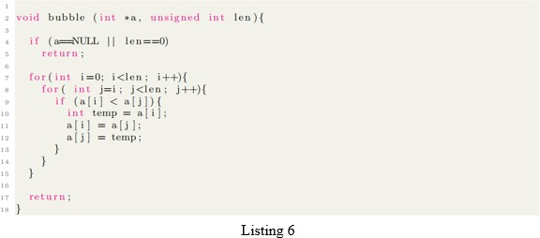

Write the equivalent RISC-V assembly code for Listing 6. a and len get passed in x10 and x11 respectively.

Code:

Output

Task 4 - Student-Selected Program
In this task, students will design and implement a RISC-V assembly program of their own choice that demonstrates the concepts covered in this lab, such as nested procedures, stack management, and control
flow.
Students are encouraged to select a program that can be extended or reused in their project. Proper use of procedure calls, register conventions, and stack discipline will be assessed. Students should clearly demonstrate correct execution of the program.

Code:

Output

Assessment Rubric
Lab 4: Implementing Nested Procedures and Sorting

Name: M. Abdullah Asim, Maaz Ahmed Siddiqui | Student ID: ma10020, ms09980 | Section: T3

Points Distribution

 | Task No. | LR 2  Code | LR 5  Results
In - Lab | Task 1 | /10 | /5
 | Task 2 | /10 | /5
 | Task 3 | /15 | /10
 | Task 4 | /15 | /10
Total Points: 100 |  | /50 | /30
CLO Mapped |  | CLO 2

Affective Domain Rubric |  | Points | CLO Mapped
AR7 | Report Submission / Git Upload | /10 & /10 | CLO 2

CLO | Total Points | Points Obtained
2 | 100
Total | 100

For description of different levels of the mapped rubrics, please refer to the Lab Evaluation Assessment Rubrics and Affective Domain Assessment Rubrics provided here.

